Assignment 6- Using Jenkins get code form github and build in Jenkins and deploy to Apache Server
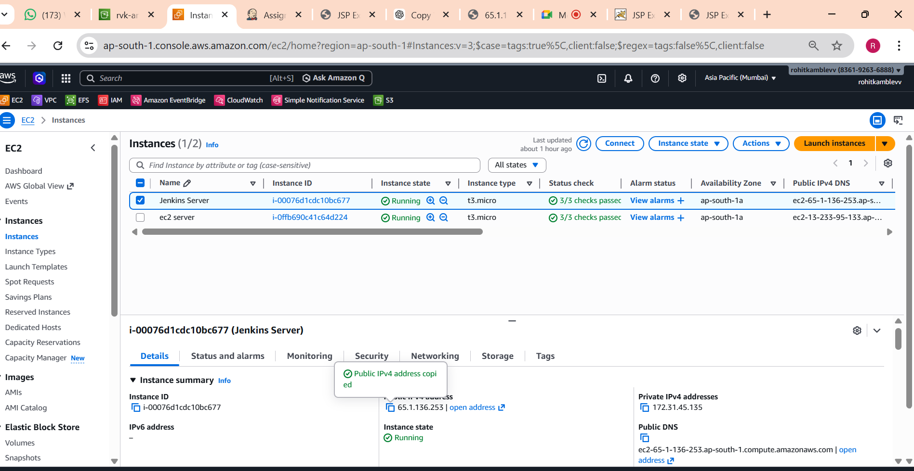
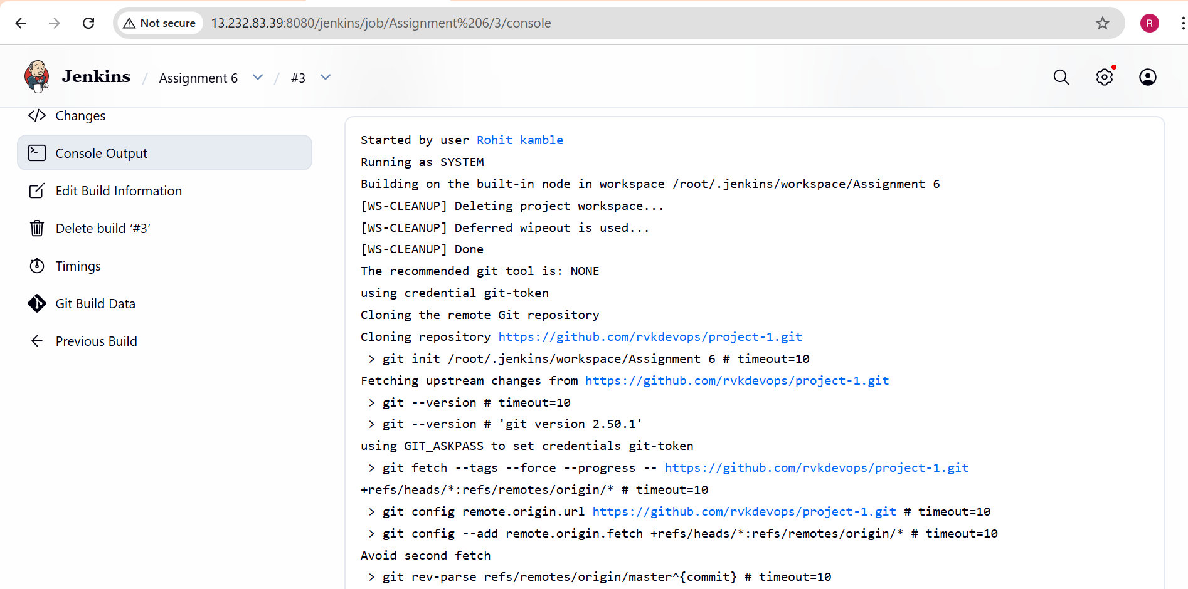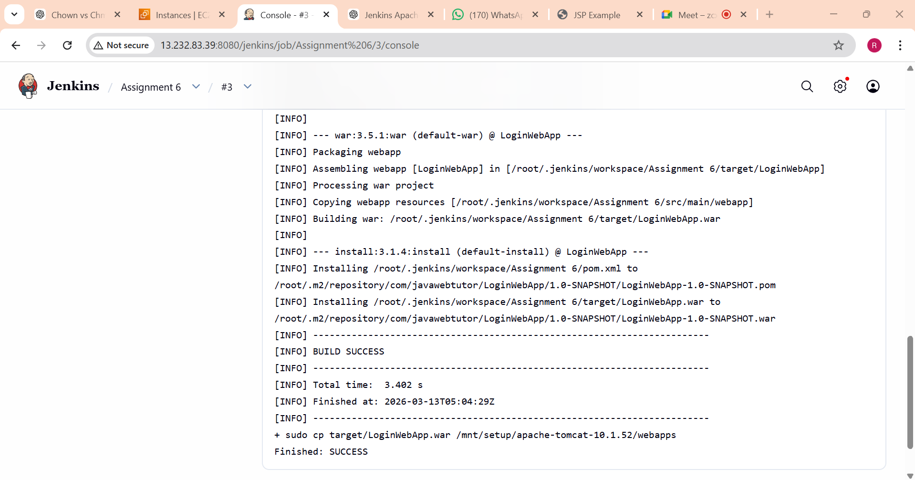

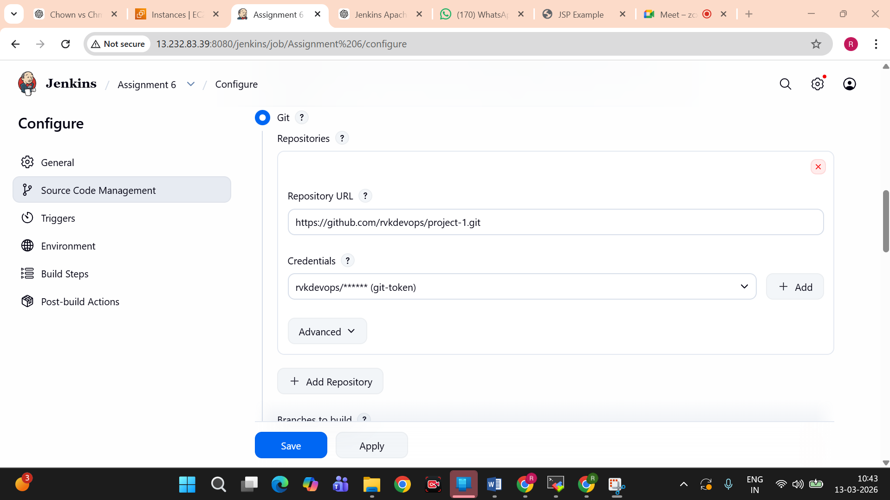

scp -r -i /mnt/Mumbai.pem target/LoginWebApp.war ec2-user@13.233.95.133:/mnt/server/apache-tomcat-10.1.52/webapps/
ssh -i /mnt/Mumbai.pem ec2-user@13.233.95.133 -yes "sh /mnt/server/apache-tomcat-10.1.52/bin/startup.sh"
